Y2K

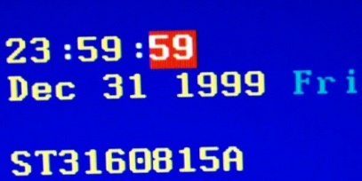

The Y2K bug also known as the Millennium bug was a problem in the coding of computerized system that was projected to create havoc in computer networks and software in the transition from 31 December 1999 to 1 January 2000.

In the late 1990’s developers used a two-digit system to store years so that they could save memory. The number ‘92’ would correspond to the year 1992. The problem with this method is that the computer assumes that before the two-digit number come ‘19’. This caused date-related programs to malfunction past 1 January 2000. To make things worse 2000 was also a leap year.

There were concerns that this would cause software and hardware failures in critical sectors of society such as banking, utilities systems, government records and so on.



It was believed that not just computers running conventional software but many other devices containing computer chips were vulnerable to this bug. Medical equipment, elevators and so many other devices required checking for sensitivity to calendar dates.

In the late 90’s there was a race to fix software before 1999 deadline. In USA while some companies were doing reasonably well, experts believed that the federal and state government were falling behind. The president Bill Clinton even signed a law to encourage the companies to share their progress in solving this bug.

In Europe the European Commission declared that the efforts to solve this issue were insufficient which prompted the United Kingdom to offer army assistance to British police forces.

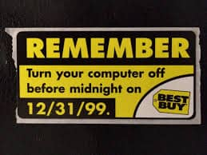Despite the treat when the day came the computer systems around the world remained intact. The people who had worked to solve this bug insisted the problem was real and that it would have caused chaos and system failures. Although media made accusations that the Y2K had been extremely exaggerated from the beginning, experts said the danger was real and was only mitigated through the collective effort of everyone around the world.

It is believed that all the implementations costed over 300 billion dollars, some reports appointing to 500 billion.

The real problem is that the Y2K was not really solved but merely delayed. In 2038 we will face the exact same problem as the system now employed is counting the seconds since 1 January 1970 and storing it as signed 32-bit integer. This makes it so the largest number that can be stored represents 03:14:07 UTC on 19 January 2038.

The question remains if the next time we face this problem we can develop a more permanent solution or if we can only delay the problem once again and how much it will cost. But if we cannot solve it we will find out how correct were the predictions in the 90’s about the chaos that would unravel if we hadn’t solved the problem back then. We must also consider that our society is already much more dependent of technology that it was back then and will probably be even more dependent in ten years.

Sources:

- <https://www.britannica.com/technology/Y2K-bug>

- <https://www.rankred.com/biggest-software-failures/>

- <https://en.wikipedia.org/wiki/Year_2038_problem>